Name_________________________________ Period _____________ Date ________________



**Lesson 6: How Do Changes in the Concentration of Water Vapor Affect Climate?**Water exists in all three phases (solid, liquid, and gas) in Earth's atmosphere. The percentage of water vapor in Earth’s atmosphere varies from about a trace over deserts to about 4% over the ocean areas. Can the concentration of water vapor in the atmosphere impact global climate change?  
  
**Doing the Science**

1. Start the Weather simulation. Click the "Change Factors" button.
2. Click the "Change Factors" button.
3. Select "Water Vapor" from the "Choose Factor" pull-down menu.
4. Select "+15%" from the "0%" pull-down menu. Click the "Apply change" button.
5. Click the "Spin" button.
6. A red icon indicates an increase in temperature of 0.1 ºF. A blue icon indicates a decrease in temperature of 0.1 ºF. The green dot in the graph at the top of the screen displays the net change in temperature over the 30-year period. Record your data in the graph below.
7. To speed the spin rate up, click on the green "Faster" icon next to the "Spin" button.
8. Repeat steps 5 and 6 until you complete a total of 20 spins.
9. Make sure to record your data in the graph below.

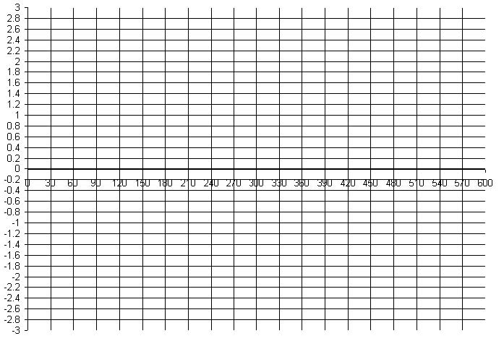

Number of years

Temperature difference from average yearly temperature (in °F.)

**Do You Understand?**

1. Was the graph of the temperature data showing above average, average, or below average temperatures during most of the 600 years of data?
2. Based on temperature, was the climate changing in the area over which the temperature data were collected? Discuss your reasoning for your response.
3. Change the percentage of water vapor in the atmosphere by repeating step 3. Make sure to select a different % value in step 4. Repeat steps 5 -9. Discuss how the average temperature changed as a result of this new percentage of water vapor. Write a generalization as to how global temperature is affected by the concentration of water vapor in the atmosphere.